**CONNECTION AND DATA LOADING STEPS**

1. **LOADING DATA IN MONGODB**

**METHOD 1**

**STEP: LOAD DATA WITH R SCRIPT:**

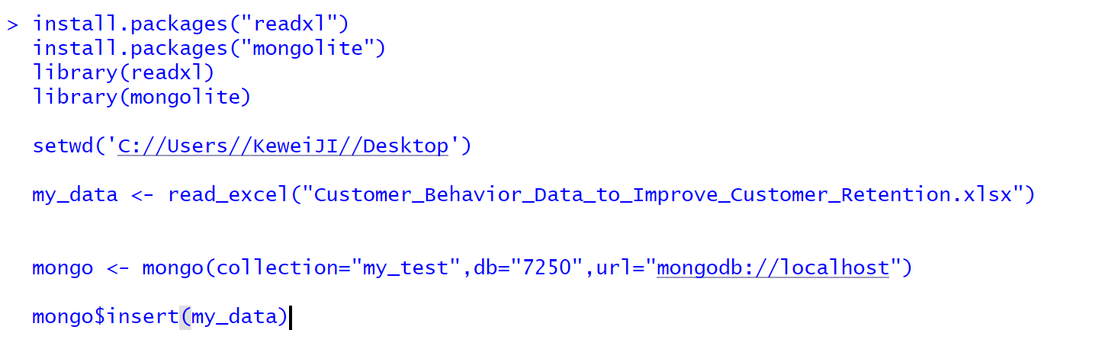

**STEP: DATA IN MONGO SHELL**

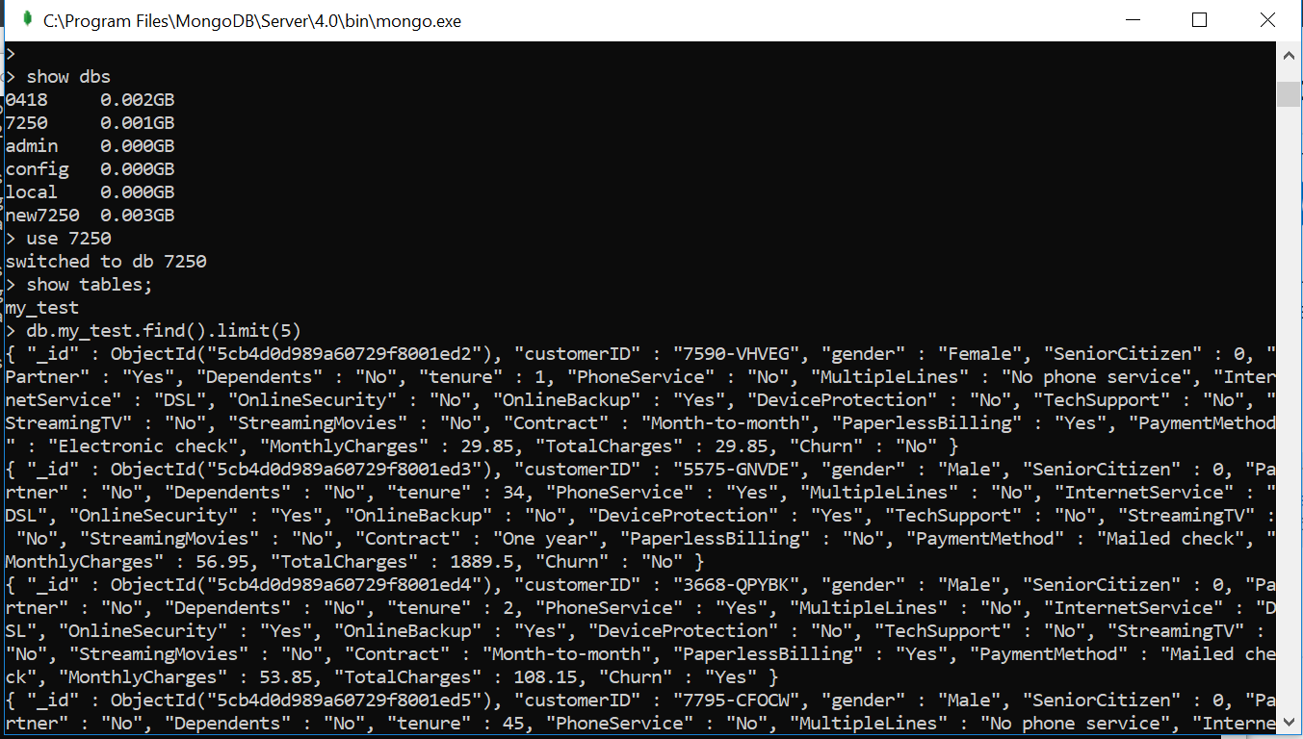

**METHOD 2**

**STEP: Go to MongoDB Atlas and create a Database and collection**

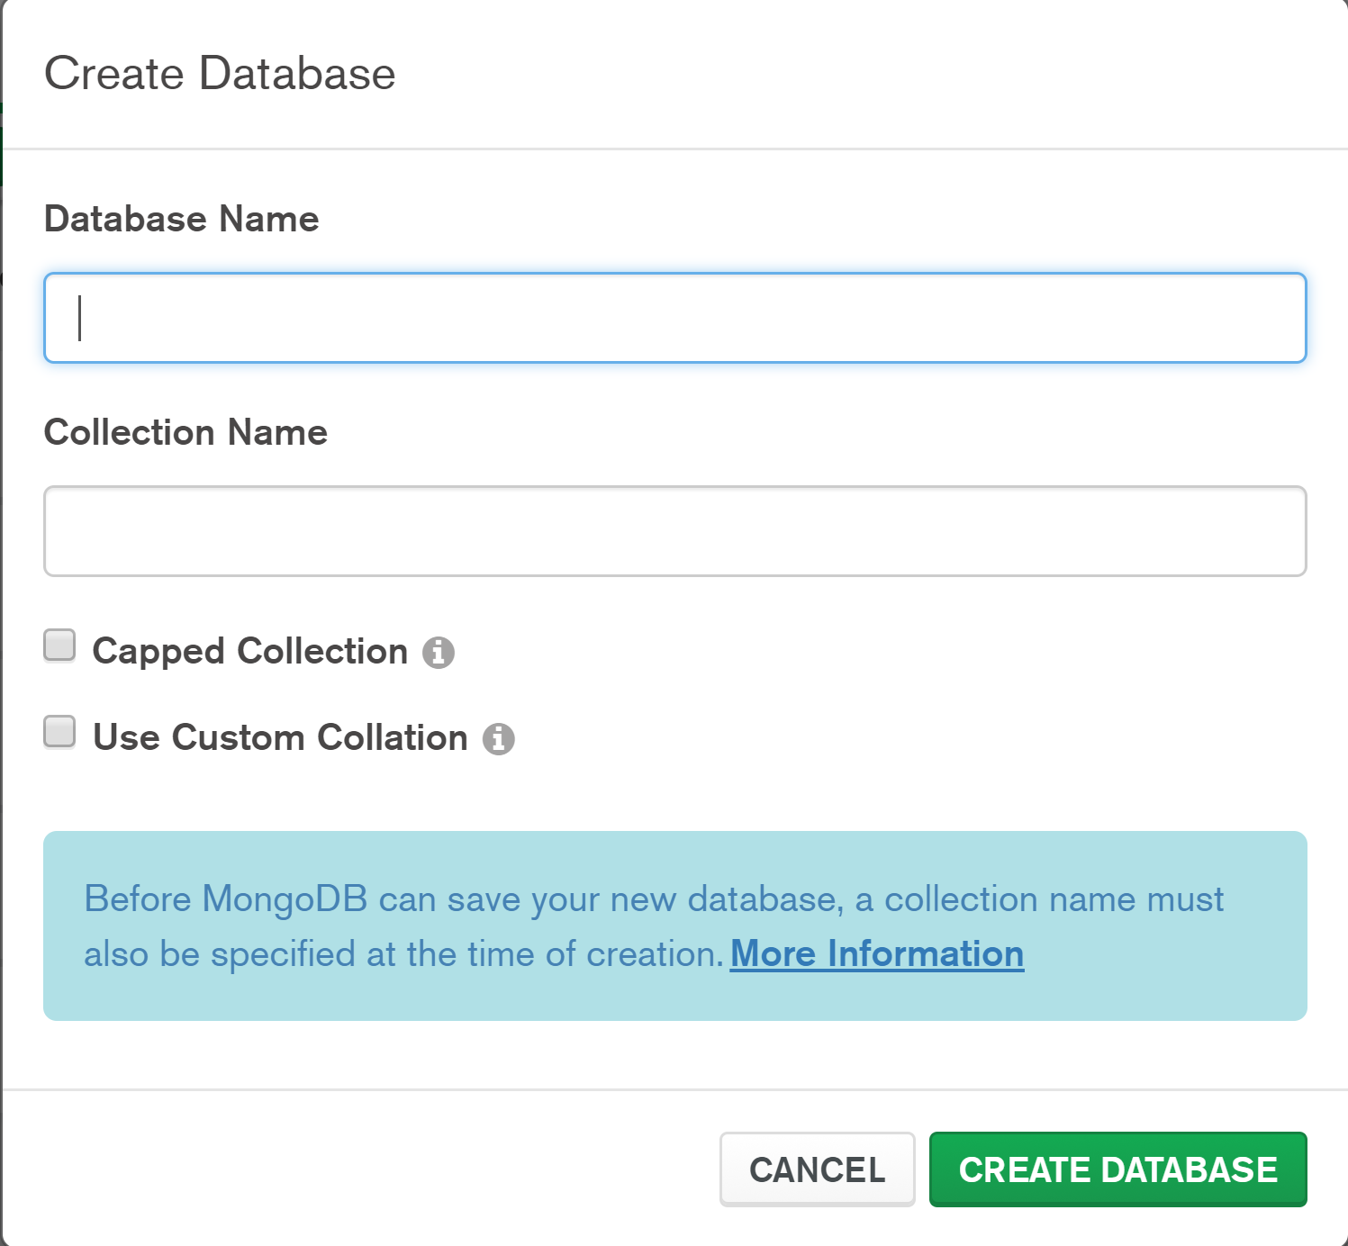

**STEP: In the collection tab select Import data and select the CSV file format.**

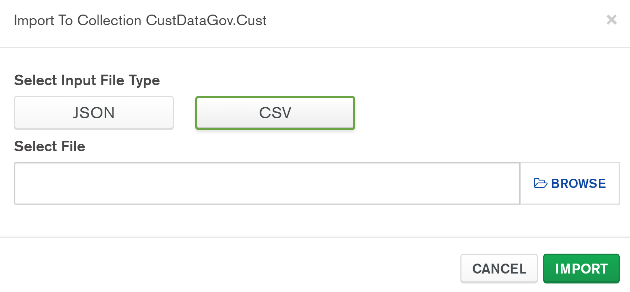

**STEP: Output after successful loading**

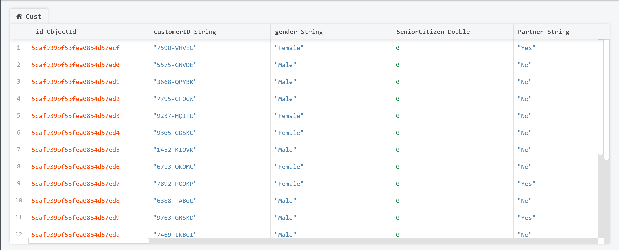

1. **Connecting MongoDB to Power BI**

**METHOD 1**

**STEP 1: Start the ODBC administrator and create the MongoDB connection**

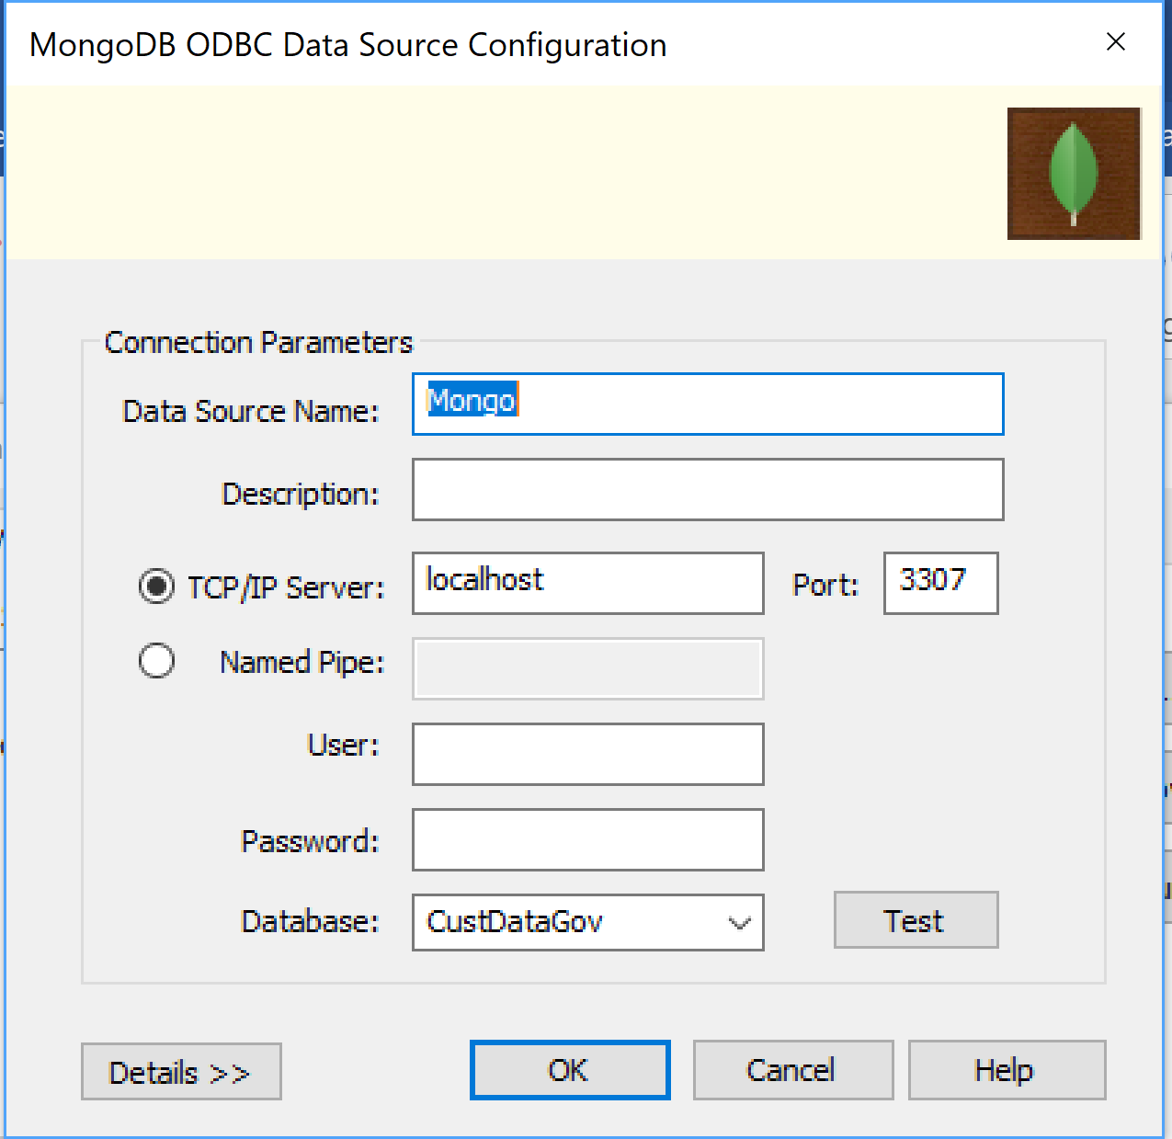

**STEP: Go to the location of MongoDB BI connector and start cmd and run mongosqld command**

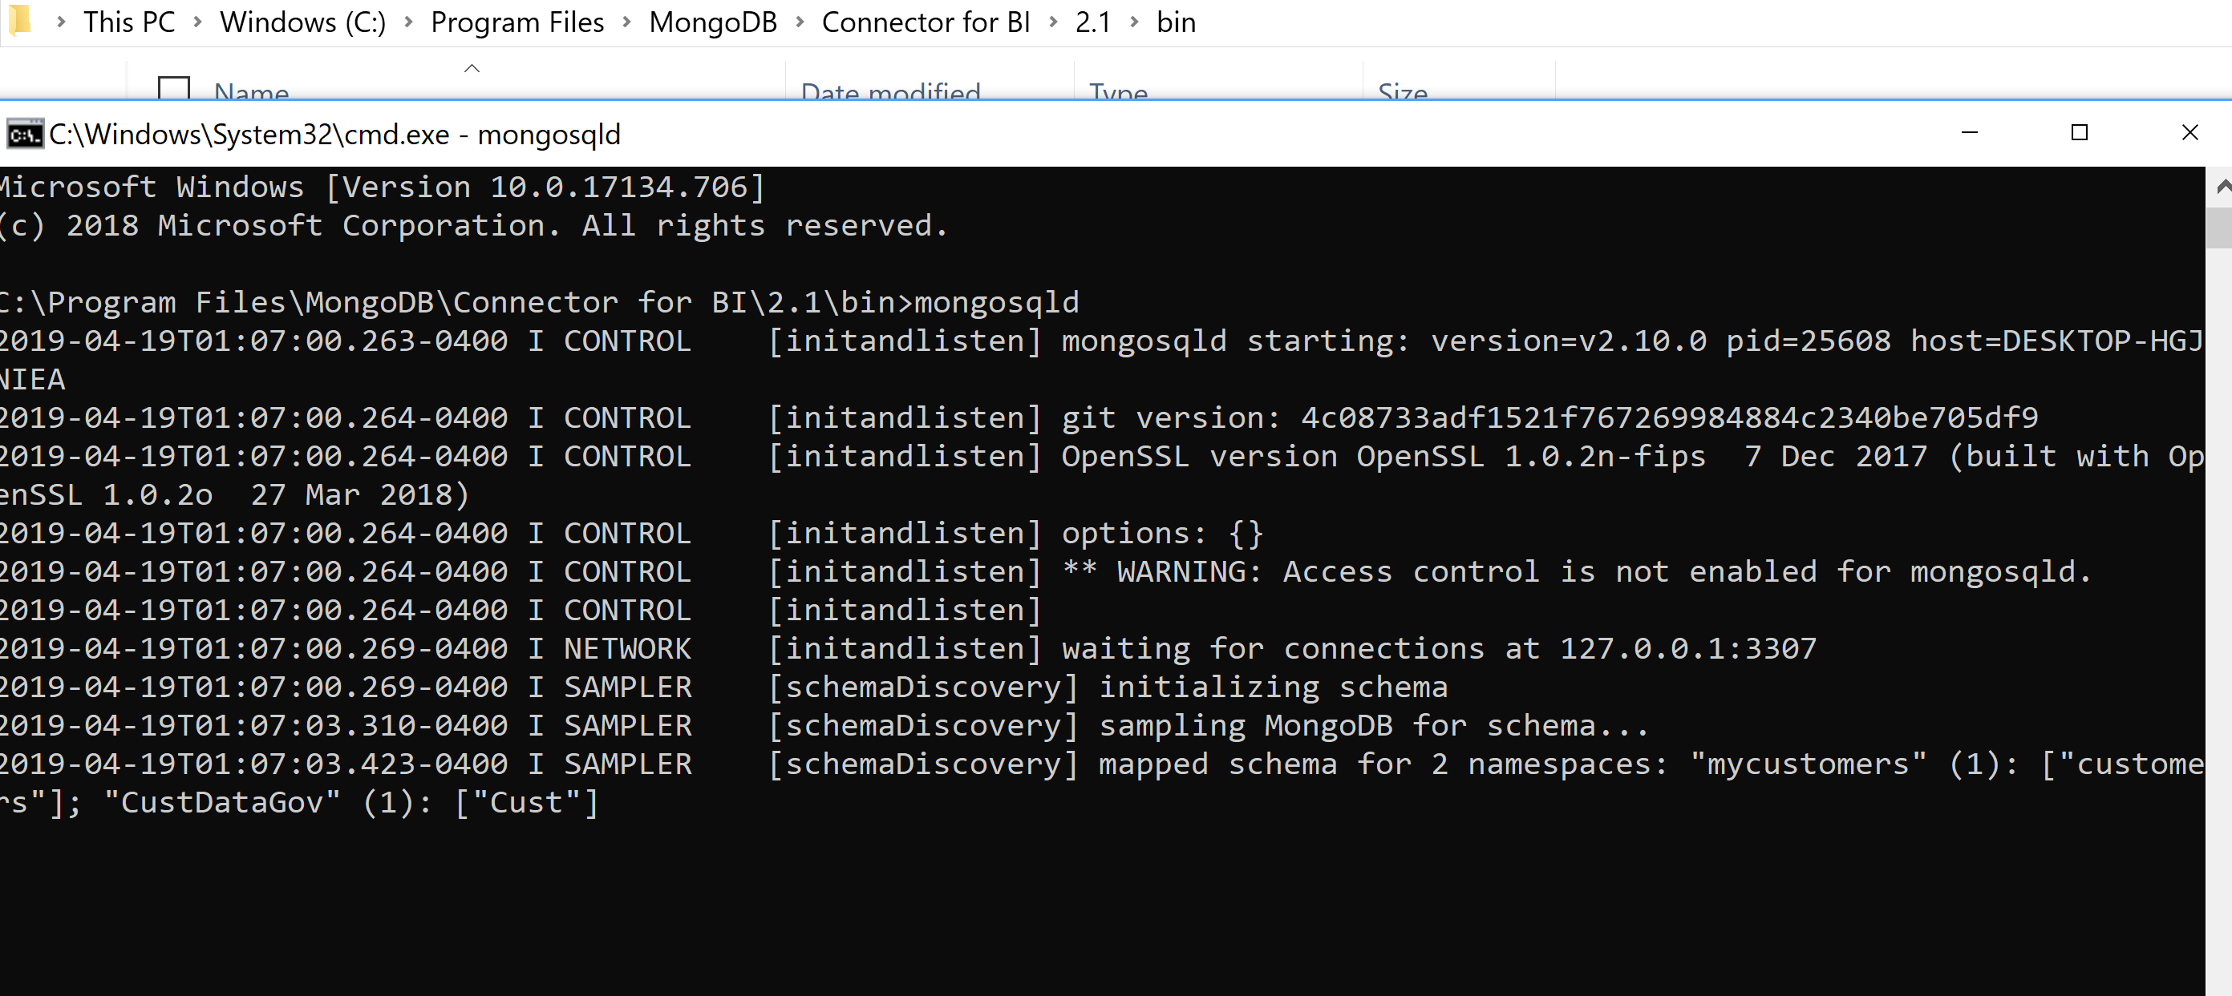

**STEP: Go to Power BI and in Get data select ODBC and select the MongoDB connection name.**

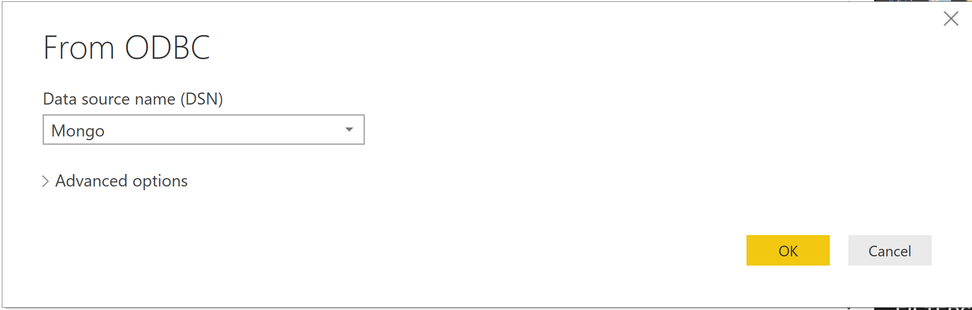

**STEP: Select the database name and the collection to load data**

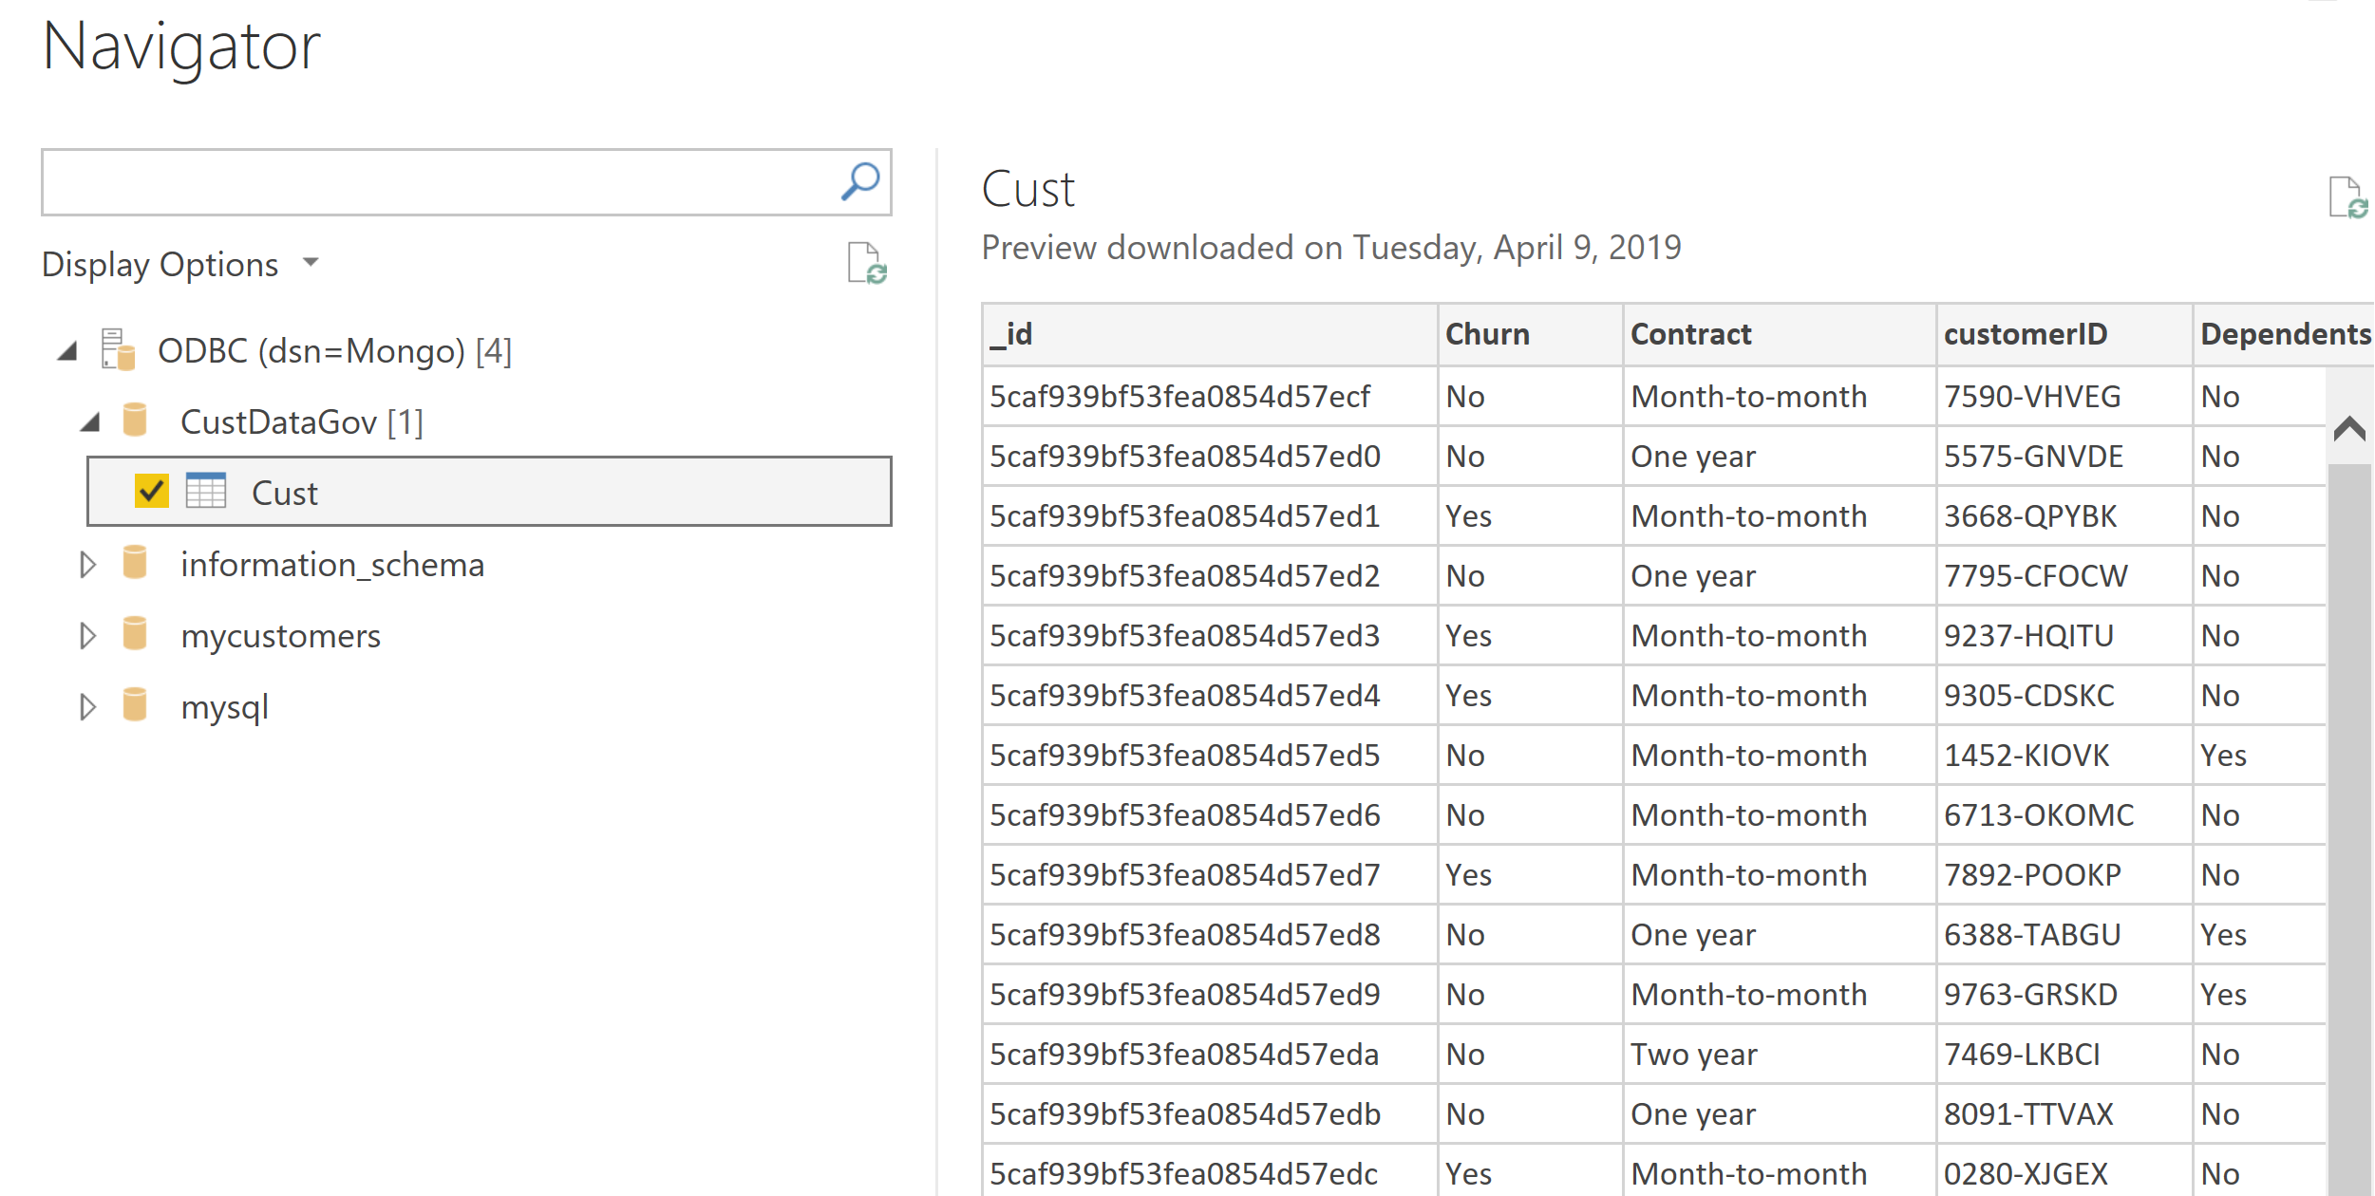

**STEP: Data in Power BI**

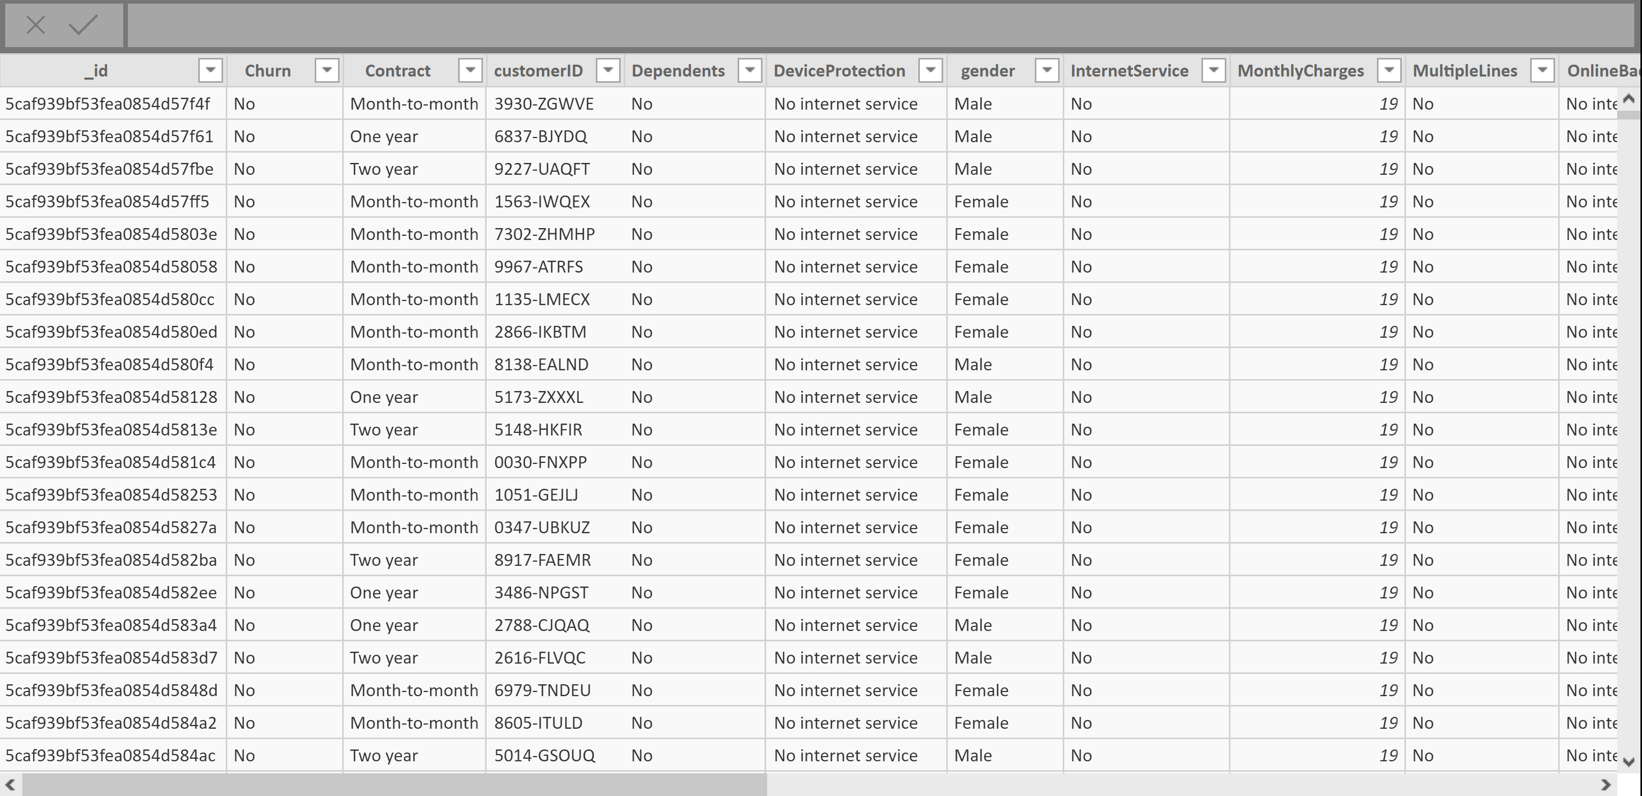

**METHOD 2**

**STEP: Use R script connector in power Bi and write the R script**

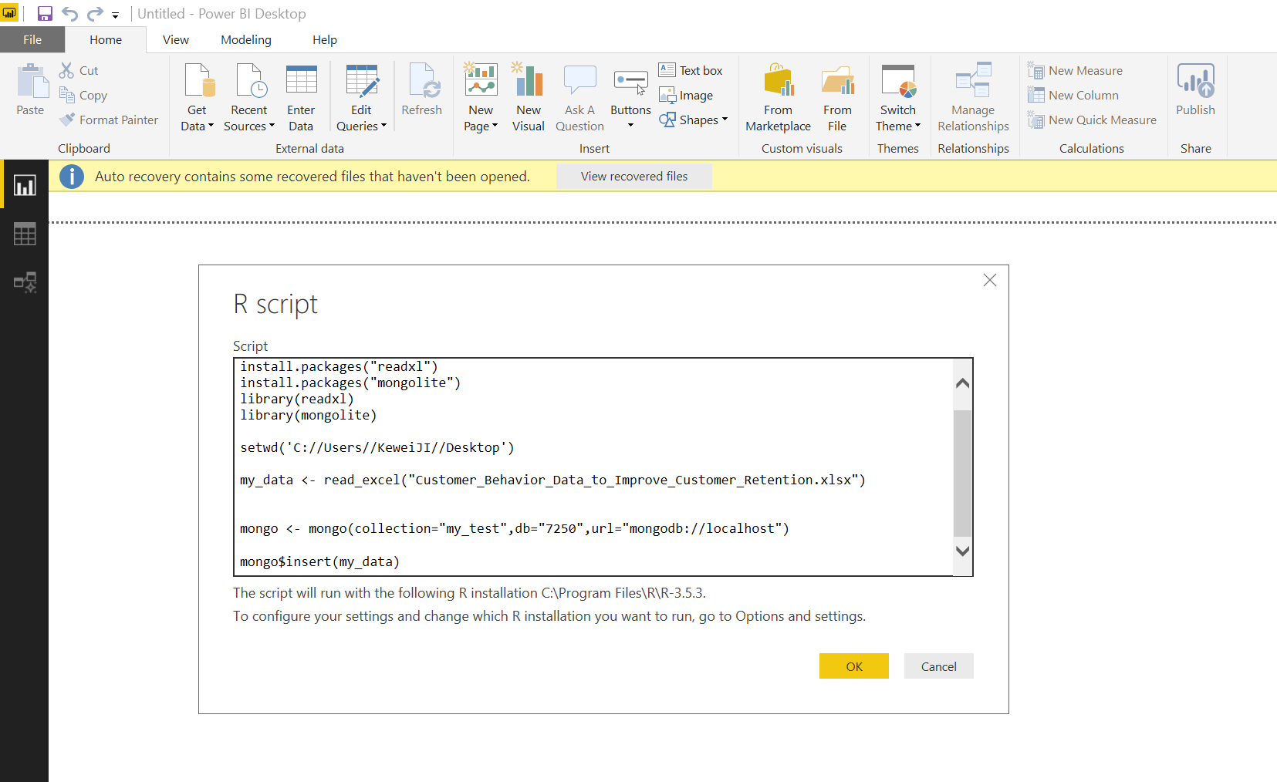

**STEP: Data in power BI**

